Route Valldemossa (The Mick Potts)  Full ride  Pto Pollensa (through town, main road ) – Pollensa – Lluc – Puig Major – Soller– Deia – Valldemossa – Palmanyola – Sta Maria  ‘Easier’ ride (blue dots on map)  From Soller: – Bunyola – Santa Maria (dotted blue on map)  ‘Easiest’ ride (solid blue on map)  From Lluc: – Selva – Lloseta – towards Alaro – Orient – Bunyola – Sta Maria (solid blue on map)  All rides  Sta Maria – Water Lane - (to get to Water Lane go out of Santa Maria take 1st right to Sencelles; take 1st left (in some houses); take care, easy to miss) – Sa Pobla – marshes – Alcudia – Pto Pollensa  Comments  1st group 09.00  2nd group 09.30  3rd group 10.00  This is a long, tough day for all groups; earlier times are the slower riders. Pick a group to suit your own level.  Easier rides will NOT be supported after Lluc or Soller until we reach Santa Maria so make sure you have enough water and provisions. | 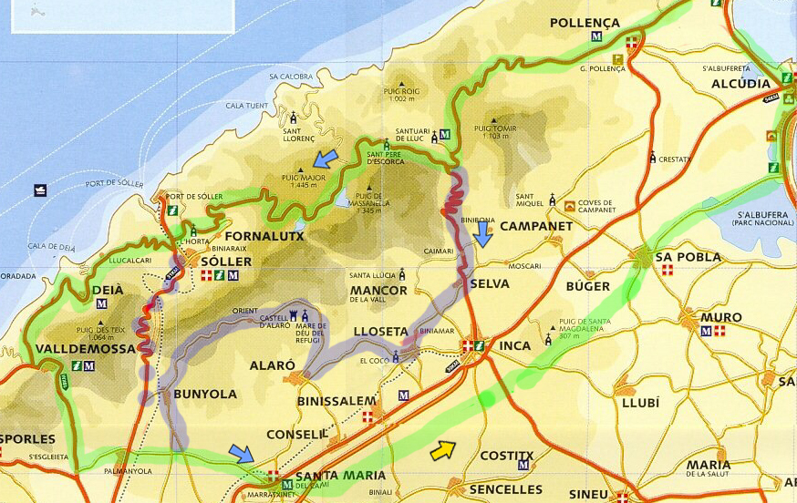
Route Binissalem  A fairly short easy ride designed to follow the Big Mick  All Groups  Back lane – bumps road – Campanet – Selva – Lloseta – Binissalem  Binissalem – Water Lane – Sa Pobla – Alcudia – round the bay | 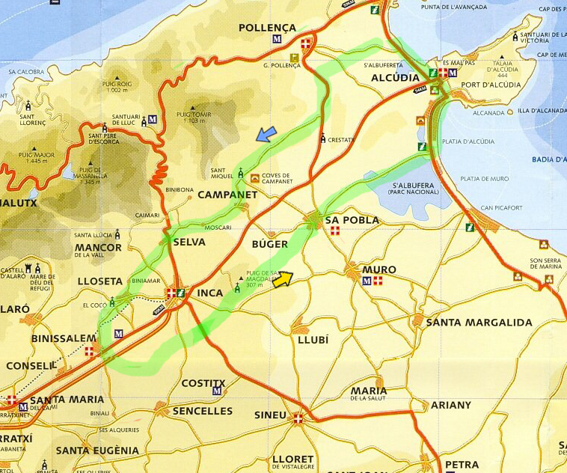
Route San Salvador  All groups  Pto Pollensa –Alcudia (or use back lanes inland from the main road)– Ca’n Picafort – Son Serra – Right off main road towards Manacor ––Manacor  (right onto main road, left onto main town street by bike shop (Mean si Torn), 2nd set lights turn right; downhill watch out for traffic crossing; @ bottom turn left; watch out for building with T. T. SERRA painted on side; right; continue along lane; @ first crossroads turn left (if you get to a T junction you’ve gone too far and are heading for Vilafranca))– Fellantix – San Salvador (visit the monastery which is on the right of the road to Porto Cristo, to see Timoner’s rainbow jerseys for motor-paced track racing).  San Salvador – Fellantix – Petra – Ariany via back lane from Petra – Maria – Muro – Sa Pobla – marshes – Aldudia – Pto Pollenca | 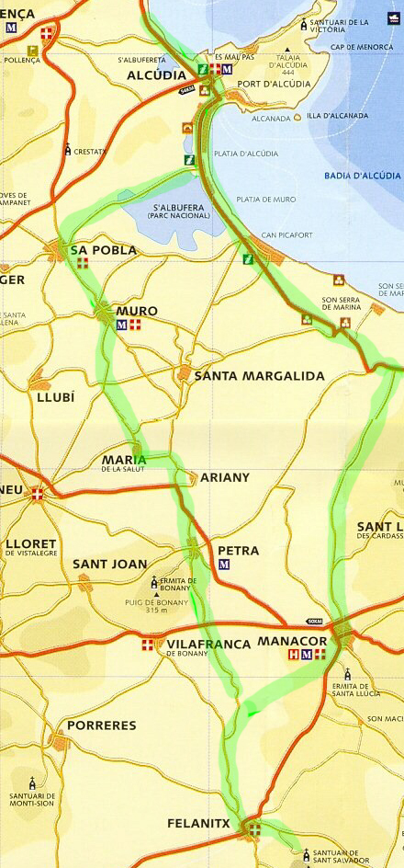
Route Lluc and Sa Calobra  When doing Sa Calobra it’s important to get there as early as possible, to avoid the cars and coaches which can be, fairly obviously, dangerous obstructions  All Groups  Pto Pollensa – Lluc –  Group 1  Gorge Blau (viaduct/café junction) – Sa Colobra – (steep descent) – return to Gorg Blau – Lluc – either Pollensa – Pto Pollensa, or follow the other groups to  All Groups  Lluc – Selva – Inca – Llubi – Sineu (coffee stop) – Santa Margalida – Son Serra – Ca’an Picafort – Alcudia | 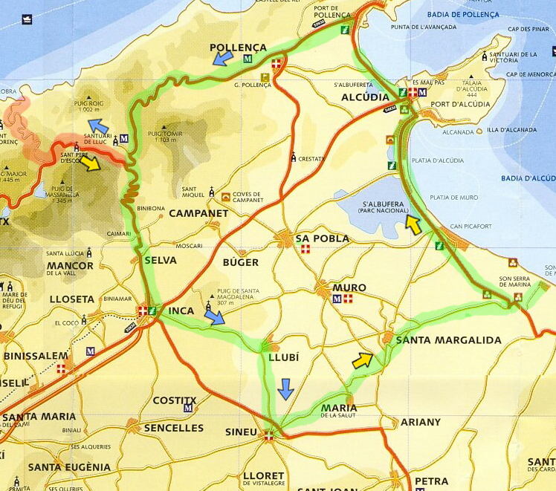
Route Petra  All Groups  Pto Pollensa - Pollensa (via back lane, main bay road, Golf Club, as selected by ride leader)  Group 1  Campanet – Buger – Sa Pobla  Group 2  .Bumps – Sa Pobla  All groups  Sa Pobla (Follow new ring road to the left. At the junction with the Muro road, turn right towards the town, take first left to join Llubi road where turn left. This cuts out the town centre) - Llubi – Sineu  Sineu – at Sineu turn left to skirt the town; as the road swings round to the right don’t take the first left turn to Petra, continue for another hundred metres then left turn- San Joan (watch out for sharp right/left in the middle of town) - Petra  Take the back way out of Petra, left onto little lane as the main road swings to right, right at T, left just before the main road, long lane to Maria de la Salut – Muro – Sa Pobla - via marshes to Alcudia - Pto Pollensa | 

